**M S Ramaiah Institute of Technology**

(An Autonomous Institute, Affiliated to VTU)

MSR nagar, MSRIT post, Bangalore-54

A Design Document on

**Effective prevention and prediction of air pollution caused by automobiles using IOT and Data Analytics techniques**

Under the guidance of

Dr. S Seema

(Associate Professor, CSE)

Submitted by

Adarsh Raj 1MS12CS005

Anvitha D Rao 1MS12CS010

Vishal Mahuli 1MS12CS134

Vishwanath 1MS12CS135

*In partial fulfillment for the award of the degree of*

***Bachelor of Engineering in Computer Science & Engineering***



**DEPARTMENT OF COMPUTER SCIENCE & ENGINEERING**

**M.S. RAMAIAH INSTITUTE OF TECHNOLOGY**

**(Autonomous Institute, Affiliated to VTU)**

**BANGALORE-560054**

[www.msrit.edu](http://www.msrit.edu/), **May 2016**

**INTRODUCTION**

The aim of this project is to effectively prevent and predict the air pollution caused by the automobiles using Arduino board, two gas sensors (MQ-7 and MQ-135) and a Wi-Fi module.

These components serve the IOT part of the project. The remaining half of the project is all about data analytics on data collected from various sources primarily, Karnataka State Pollution Control Board. The sensors sense the gaseous levels present in the effluents and emissions coming out of the exhaust and based on the threshold value set, the processor board decides whether an alert is to be sent to the owner or not about the emission level exceeding. These values are also sent by Wi-Fi module from the board to a specific IP so as to collect and analyze the data from every specified owner. An android application is also built to support the most important feature of the data analytics part i.e. Routing based on pollution levels in the cities.

We propose this system as this idea was brainstormed by referring to few IEEE papers and by using ideas of our own about the prevention of air pollution and how it is to be controlled. This system has various features which on implementation will affect the strategy of curbing the air pollution to a huge extent. We have the feature in which the system chokes/cuts down the fuel supply once the vehicle is not serviced in the allotted time period. The android application is basically for the routing feature which is based on suggesting you route based on pollution levels.

IOT is an emerging field and is the technology which is helping in automating almost everything. Data analytics always provide clear insights out of humongous data sets and helps to derive conclusions out of it. We try to use the benefits of both these fields into one concept which in today’s world is a burning topic i.e. AIR POLLUTION. This system is going to bring a revolutionary change to the entire concept of prevention to the air pollution and its control measures.

The Android application also provides the history of the emission records and also provides tips which we call “Tip of the day/week”. This tip is a small fact which can help spread awareness about the air pollution prevention and how some preventive measures can prove effective in this regard. Routing of the areas are based on the ranks assigned to them after the data from that area is being analyzed. Arduino is a cheap and compact but highly effective board, and has an A-to-D convertor in-built which is not there in RasberryPi board also. Hence we have chosen this board. Internet connectivity is very important in this system as every communication is dependent on it.

**Modular design**, or "modularity in design", is a design approach that subdivides a system into smaller parts called modules or skids, which can be independently created and then used in different systems. A modular system can be characterized by functional partitioning into discrete scalable, reusable modules, rigorous use of well-defined modular interfaces, and making use of industry standards for interfaces.

Thus this document initially describes the different modules present in the project. It is then followed by the various algorithms that are used to implement the modules. Later the system architecture is described which is followed by the description of the GUI and then various UML diagrams like class diagram, sequence diagram and data flow diagram are given. Finally, the document ends with the list of references used in developing this document.

The different modules needed for the project.

* **Gas Sensor Module**: This module is responsible for identifying the change in the NO2 and CO2 values in vehicles.In this module all the values are rechorded and monitered.

* **Aurdino Module:** This module is the most important module in the project. An embedded c program is written and flashed to the Aurdino. This program ensures that the data is being read from the Gas sensors and also make sure that this analog voltage is converted to a digital value and is sent to the Database application using the Wifi module. Further suitable messages are sent to users and Air Pollution Control Board.

* **Wifi Module**: This module is responsible for interfacing a Wifi board with the Aurdino to ensure that data communication takes place between the Android Application running on the user’s phone and the Audino.
* **Database Module**: This module’s function is to insert the data into Online cloud and maintain structured data.This is responsible reducing redundancy and to Provide data for data analytics.
* **Data Analytics Module**: This module’s function is for Air Pollutoin control Boad to manage the Air Pollution Causing vehicals and to even Analyse the Pollution data with graphs and charts.
* **Android Application Module**: This Module is for the user to analyse thier vehicle Emission values periodically and to have notification when it exeeds the emmission control value.It will also provide and Map accordingly from data collected through aurdino which will be resulted in providing Alternative Route accordingly with less Air Pollution.

**ARCHITECTURE DESIGN**

A **system architecture** or **systems architecture** is the conceptual model that defines the structure, behavior, and more views of a system. An architecture description is a formal description and representation of a system, organized in a way that supports reasoning about the structures and behaviors of the system.

System architecture can comprise system components, the externally visible properties of those components, the relationships (e.g. the behaviour) between them. It can provide a plan from which products can be procured, and systems developed, that will work together to implement the overall system. The different modules present in this project has been described in the introduction. The system architecture is given in Figure.

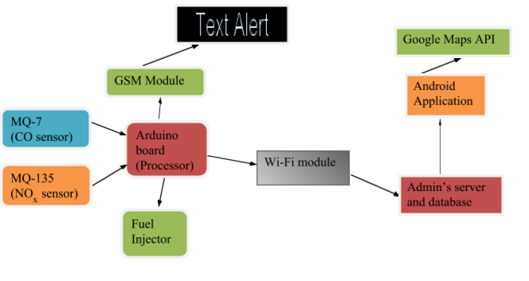

**System Architecture**

**GRAPHICAL USER INTERFACE**

The main graphical user interface is an Android Application which communicates with Cloud which intern communicates with Aurdino vai Wifi Module. This application initially has a welcome login page for authentication with two buttons, namely login and Register. When the user enters the correct username and the password the login succeeds and redirects the application to the main page where a His vehicals Recent Emission data will be is displayed. If either the username or the password is invalid, then it prompts the user to enter the correct credentials. The Emission Data is generated depending on the voltages values of the 2 Sensor's CO2 and NO2 received via Bluetooth from the Aurdino. Thus the user’s Vehicals activities are identified on the basis of the voltage values a bar chart is generated to indicate the values of emission test. Further the Android application also has a button to view the activities performed by the user in the past to provide persistent storage. The GUI also has a button to genarate direction from one location to another location with minimunThe GUI has been planned to designed very efficiently so that it’s user friendly and at the same time has a good look and feel. The different functions used are ***loginButton, registerButton, viewData, processData, generatePie and genarateDirection***. Thus the Android application acts as the software graphical user interface.

**Data Flow Diagram:**

* A **data flow diagram** (**DFD**) is a graphical representation of the "flow" of data through an information system, modelling its processaspects. A DFD is often used as a preliminary step to create an overview of the system, which can later be elaborated. DFDs can also be used for the visualization of data processing (structured design).
* A DFD shows what kind of information will be input to and output from the system, where the data will come from and go to, and where the data will be stored. It does not show information about the timing of process or information about whether processes will operate in sequence or in parallel (which is shown on a flowchart).
* The entire flow of the system has been shown in the data flow diagram and every step has been decided based on the system modules and their respective functionality. The flow of the main process of the system has been shown in the figure (IoT Module).

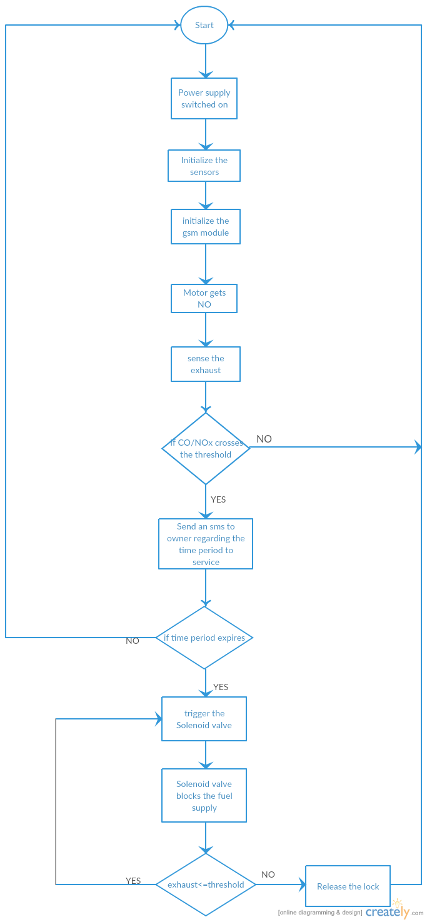

**CLASS DIAGRAM:**

* In software engineering, a class diagram in the Unified Modelling Language (UML) is a type of static structure diagram that describes the structure of a system by showing the system's classes, their attributes, operations (or methods), and the relationships among objects.
* The figure in the next slide represents the class diagram for wireless temperature monitoring system which uses association, aggregation, composition and generalization and many more features of the class model.
* The relationship among various classes and their interdependencies are effectively modeled using the class diagram.

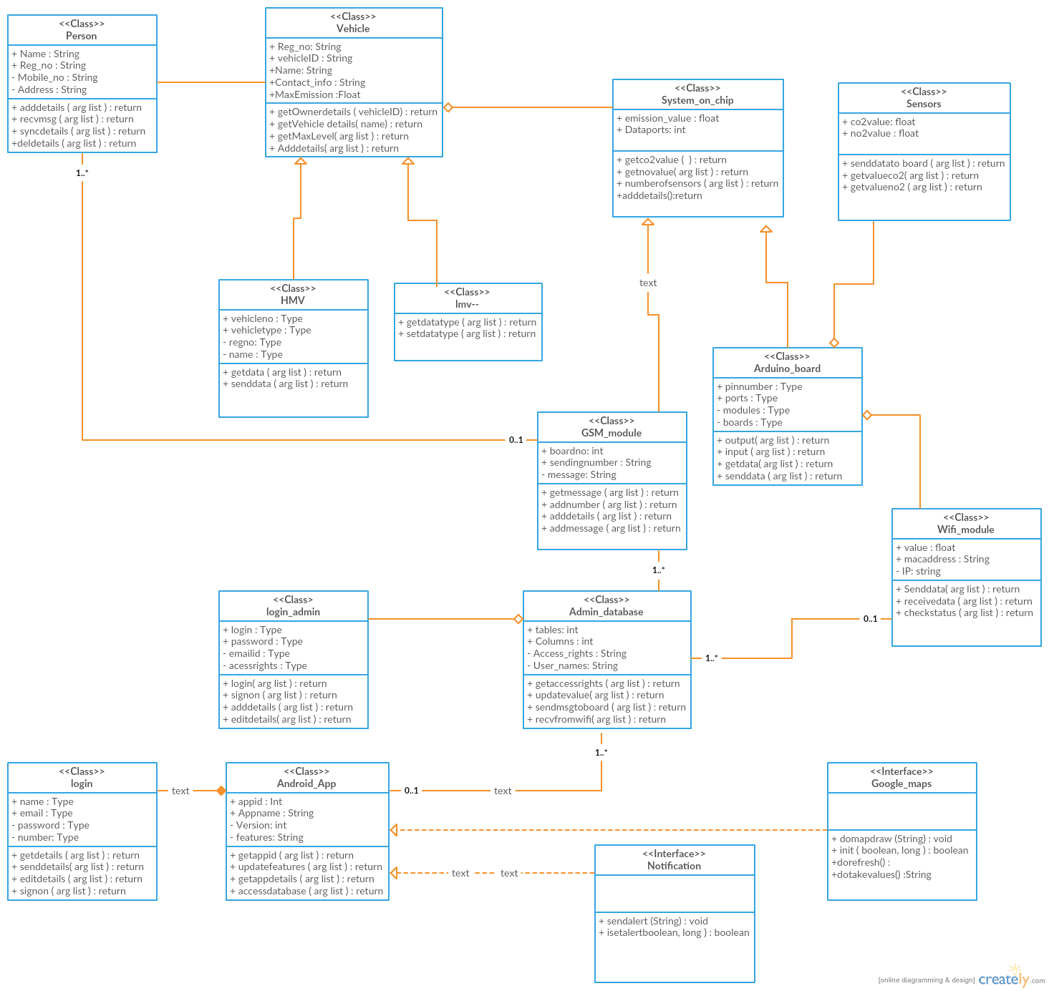

Class Diagram for the air pollution prevention and prediction system

**SEQUENCE DIAGRAM:**

* **Sequence diagram** is an interaction diagram that shows how processes operate with one another and in what order. It is a construct of a Message Sequence Chart. A sequence diagram shows object interactions arranged in time sequence. It depicts the objects and classes involved in the scenario and the sequence of messages exchanged between the objects needed to carry out the functionality of the scenario. Sequence diagrams are typically associated with use case realizations in the Logical View of the system under development. Sequence diagrams are sometimes called **event diagrams** or **event scenarios**.
* A sequence diagram shows, as parallel vertical lines (*lifelines*), different processes or objects that live simultaneously, and, as horizontal arrows, the messages exchanged between them, in the order in which they occur. This allows the specification of simple runtime scenarios in a graphical manner. The sequence diagrams for this project are as follows.
* There are various objects involved in the sequence diagrams and are clearly shown in the diagram.
* The required conditionals are mentioned in the comment box in the diagram.

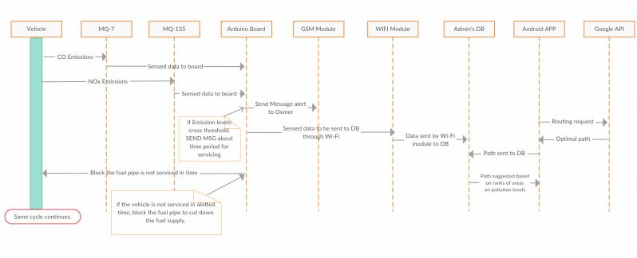

*Sequence Diagram*

**REFERENCES:**

* Anita kulkarni1 , T. Ravi Teja2 Associate Professor, Department of EIE, VNR Vignana Jyothi Institute of Engineering and Technology, Bachupally, Hyderabad, Telangana, India1 PG Student [EI], Department of EIE, VNR Vignana Jyothi Institute of Engineering and Technology, Bachupally, Hyderabad, Telangana, India2.

“**Automated System for Air Pollution Detection and Control in Vehicles**” in International Journal of Advanced Research in Electrical, Electronics and Instrumentation Engineering on 9, September 2014.

* A. R. Al-Ali, Member, IEEE, Imran Zualkernan, and Fadi Aloul, Senior Member, IEEE

“**A Mobile GPRS-Sensors Array for Air Pollution Monitoring**”.

* R.A.Roseline1 , Dr.M.Devapriya2 ,Dr.P.Sumathi3 1,2&3Postgraduate and Research Department of Computer Science, Government Arts College, Coimbatore, Tamilnadu, India.

**“Pollution Monitoring using Sensors and Wireless Sensor Networks : A Survey R.A.Roseline1 , Dr.M.Devapriya2 ,Dr.P.Sumathi3”** in International Journal of Application or Innovation in Engineering & Management (IJAIEM) on 7, July 2013.

* Sandip S. Patil, Prof. Jaykaran Singh RGPV University, Department of Electronics and Communication Engineering, SSSIST, Sehore, M.P., India

“**Monitoring and Controlling of Hazardous Gases inside Vehicle and Alerting Using GSM Technology**” in International Journal of Advanced Research in Computer Science and Software Engineering on 1, January 2015.

* <http://wiki.eprolabs.com/index.php?title=Gas_Sensor_MQ7>
* <http://www.waveshare.com/wiki/MQ-135_Gas_Sensor>
* <http://kspcb.gov.in/>
* <http://www.eolss.net/sample-chapters/c09/e4-14-00-00.pdf>
* <http://www.ijareeie.com/upload/2014/september/46_Automated.pdf>
* <http://davidhoulding.blogspot.in/2014/03/co-carbon-monoxide-gas-sensor-using.html>
* <http://wiring.org.co/learning/basics/airqualitymq135.html>
* <http://forum.arduino.cc/index.php?topic=172368.0>
* <http://www.ijarcsse.com/docs/papers/Volume_5/1_January2015/V5I1-0502.pdf>
* <http://events.awma.org/files_original/ControlDevicesFactSheet07.pdf>
* <http://www.4cleanair.org/APTI/452combined.pdf>
* <http://www.waveshare.com/wiki/MQ-135_Gas_Sensor>
* <http://www.geeetech.com/wiki/index.php/Carbon_Monoxide_Sensor_-_MQ-7>
* [www.creately.com](http://www.creately.com)
* http://www.ijaiem.org/volume2issue7/IJAIEM-2013-07-14-041.pdf